**Assignment 2**

**Draw use case diagram for your Project**

**Project Name: - Utility Store**

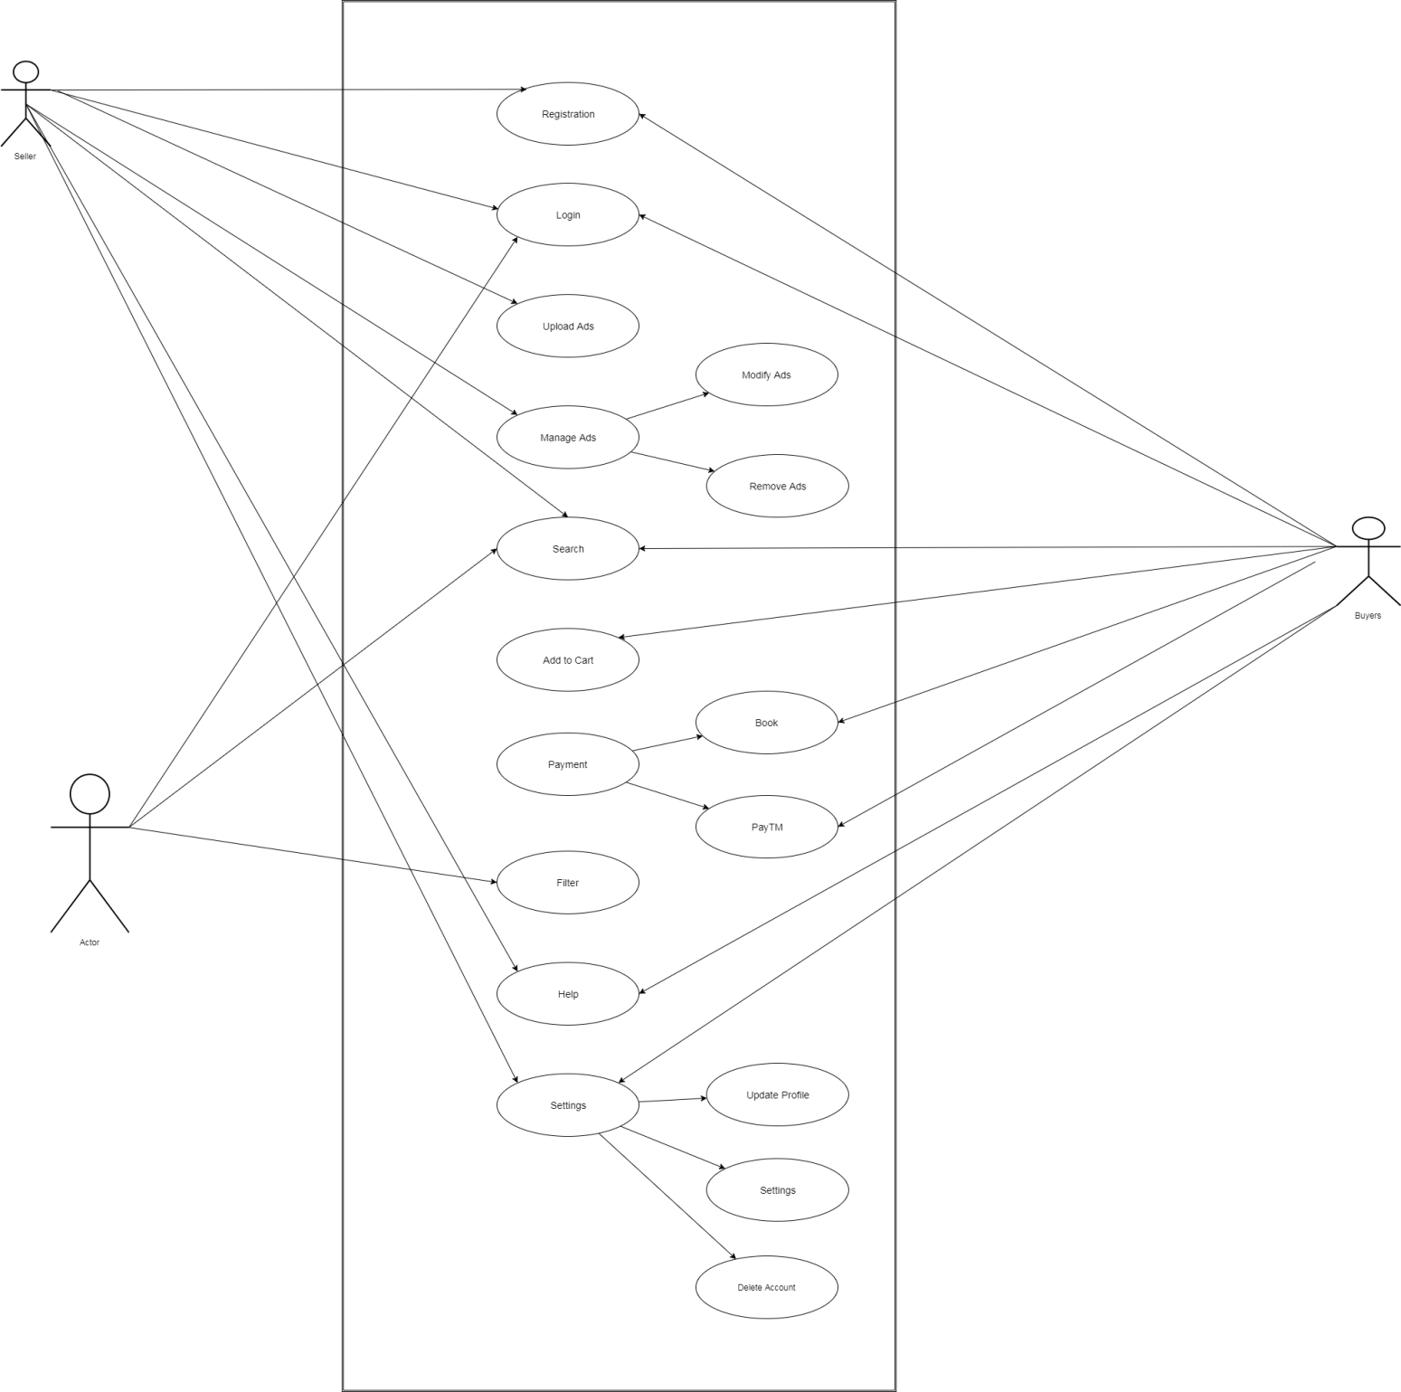**Actors: - Buyers, Sellers, Admin**

Admin